



**Informatics Institute of Technology**

**Department of Computing**

**Module: 5COSC009C – OOP**

Degree Program - BEngSE

Tutorial Group - Group D

Module Leader: Mr. Guganathan Poravi

**Overnight Coursework 04**

Student ID : 2017116

UOW Number : w1673669

Name : Vikum Sanjeewa

Table of Contents

**Introduction** 3

**Codes for the programme** 4

**1.** **Main Menu** 4

**2.** **Footer** 7

**3.** **Add Item** 8

**4.** **Book** 9

**5.** **DVD** 11

**6.** **Remove item** 13

**7.** **Borrow item** 14

**8.** **Return item** 16

**9.** **Generate Report** 17

**10.** **List items** 18

**11.** **App component HTML** 20

**12.** **Index.html** 21

**Screenshots** 22

Main menu 22

Add item menu 22

Form to add books 23

Form to add DVD 23

Remove item 24

Borrow item 24

Return item 25

Generate report 25

List items 26

# **Introduction**

This the frontend that is developed using angular and typescript. This contain web layout to insert and retrieve data for the library management system.

# **Codes for the programme**

## **Main Menu**

**HTML**

<**div** *style=***"*text-align***:**center"**>  
 <**br**>  
 <**svg** *xmlns=***"http://www.w3.org/2000/svg"** *x=***"0px"** *y=***"0px"** *width=***"50"** *height=***"50"** *viewBox=***"0 0 252 252"** *style=***"*fill***:#3498db;**"**>  
 <**g** *transform=***""**>  
 <**g** *fill=***"none"** *fill-rule=***"nonzero"** *stroke=***"none"** *stroke-width=***"1"** *stroke-linecap=***"butt"** *stroke-linejoin=***"miter"** *stroke-miterlimit=***"10"** *stroke-dasharray=***""** *stroke-dashoffset=***"0"** *font-family=***"none"** *font-weight=***"none"** *font-size=***"none"** *text-anchor=***"none"** *style=***"*mix-blend-mode***: **normal"**>  
 <**path** *d=***"M0,252v-252h252v252z"** *fill=***"none"**></**path**>  
 <**g** *id=***"original-icon"** *fill=***"#3498db"**>  
 <**g** *id=***"surface1"**>  
 <**path** *d=***"M121.15385,0c-1.62801,0 -3.40745,0.34075 -4.84615,1.21154l-111.76442,67.84615c-3.63462,2.19592 -5.33834,6.66346 -4.24038,10.90385c1.09795,4.24038 4.88401,7.26923 9.08654,7.26923h223.52885c5.14904,0 9.38942,-4.3161 9.38942,-9.69231c0,-4.08894 -2.34735,-7.64783 -5.75481,-9.08654l-110.85577,-67.24038c-1.4387,-0.87079 -2.91526,-1.21154 -4.54327,-1.21154zM121.15385,32.40865c11.50962,0 20.89904,9.38942 20.89904,20.89904c0,11.50962 -9.38942,20.89904 -20.89904,20.89904c-11.50962,0 -20.89904,-9.38942 -20.89904,-20.89904c0,-11.50962 9.38942,-20.89904 20.89904,-20.89904zM9.69231,96.92308v9.69231c0,5.33834 4.35397,9.69231 9.69231,9.69231v77.53846h29.07692v-77.53846c5.33834,0 9.69231,-4.35397 9.69231,-9.69231v-9.69231zM67.84615,96.92308v9.69231c0,5.33834 4.35397,9.69231 9.69231,9.69231v77.53846h29.07692v-77.53846c5.33834,0 9.69231,-4.35397 9.69231,-9.69231v-9.69231zM126,96.92308v9.69231c0,5.33834 4.35397,9.69231 9.69231,9.69231v77.53846h29.07692v-77.53846c5.33834,0 9.69231,-4.35397 9.69231,-9.69231v-9.69231zM184.15385,96.92308v9.69231c0,5.33834 4.35397,9.69231 9.69231,9.69231v77.53846h29.07692v-77.53846c5.33834,0 9.69231,-4.35397 9.69231,-9.69231v-9.69231zM19.38462,203.53846v19.38462h-9.69231c-5.33834,0 -9.69231,4.35397 -9.69231,9.69231v9.69231c0,5.33834 4.35397,9.69231 9.69231,9.69231h222.92308c5.33834,0 9.69231,-4.35397 9.69231,-9.69231v-9.69231c0,-5.33834 -4.35397,-9.69231 -9.69231,-9.69231h-9.69231v-19.38462z"**></**path**>  
 </**g**>  
 </**g**>  
 <**path** *d=***"M126,252c-69.58788,0 -126,-56.41212 -126,-126v0c0,-69.58788 56.41212,-126 126,-126h0c69.58788,0 126,56.41212 126,126v0c0,69.58788 -56.41212,126 -126,126z"** *fill=***"none"**></**path**>  
 <**path** *d=***"M126,246.96c-66.80436,0 -120.96,-54.15564 -120.96,-120.96v0c0,-66.80436 54.15564,-120.96 120.96,-120.96v0c66.80436,0 120.96,54.15564 120.96,120.96v0c0,66.80436 -54.15564,120.96 -120.96,120.96z"** *fill=***"none"**></**path**>  
 <**path** *d=***""** *fill=***"none"**></**path**>  
 <**path** *d=***""** *fill=***"none"**></**path**>  
 </**g**>  
 </**g**>  
 </**svg**>  
  
 <**br**>  
 <**h2**>**Welcome to Library management system**</**h2**><**br**>  
</**div**>  
  
<**div** *class=***"btn-group-horizontal btncenter"**>  
  
 <!--<h2 class="text-small-topic welcome">Select your function</h2><br>-->  
  
 <**a** *routerLink=***"/componet/form-additem"**>  
 <**button** *type=***"button"** *class=***"btn btn-primary"**>**Add Items**</**button**>  
 </**a**>  
 <**a** *routerLink=***"/componet/form-remitems"**>  
 <**button** *type=***"button"** *class=***"btn btn-secondary"**>**Remove Items**</**button**>  
 </**a**>  
 <**a** *routerLink=***"/componet/form-borrowitem"**>  
 <**button** *type=***"button"** *class=***"btn btn-success"**>**Borrow Item**</**button**>  
 </**a**>  
 <**br**>  
 <**a** *routerLink=***"/componet/form-returnitem"**>  
 <**button** *type=***"button"** *class=***"btn btn-danger"**>**Return Item**</**button**>  
 </**a**>  
 <**a** *routerLink=***"/componet/form-listitems"**>  
 <**button** *type=***"button"** *class=***"btn btn-warning"**>**List Items**</**button**>  
 </**a**>  
 <**a** *routerLink=***"/componet/form-reportgen"**>  
 <**button** *type=***"button"** *class=***"btn btn-info"**>**Generate report**</**button**>  
 </**a**>  
  
 <**br**><**br**>  
</**div**>

**CSS**

.text-small-topic {  
 ***font-size***: **large**;  
}  
h2 {  
 ***font-size***: **medium**;  
 ***text-align***: **center**;  
 ***padding-top***: 3**px**;  
}  
.welcome {  
 ***margin-left***: -43%;  
}  
button {  
 ***margin***: 10**px**;  
 ***width***: 16.65%;  
 ***alignment***: **center**;  
 ***color***: **white**;  
}  
.btncenter{

***text-align***: **center**;  
}

## **Footer**

**HTML**

<!-- Footer -->  
<**footer** *class=***"page-footer font-small special-color-dark pt-4"**>  
  
 <!-- Copyright -->  
 <**div** *class=***"footer-copyright text-center py-3 bg-dark text-color"**>**Copyright © 2018 | Westminster  
 Library Management System |  
 Developed by Vikum Sanjeewa. All right reserved.** </**div**>  
 <!-- Copyright -->  
  
</**footer**>  
<!-- Footer -->

**CSS**

.text-color {  
 ***color***: **white**;  
}

## **Add Item**

**HTML**

<**h2**>**Select item type**</**h2**>  
  
<**br**>  
<**div** *class=***"d-flex justify-content-center"**>  
  
 <**div** *class=***'col-lg-3'**>  
 <**a** *routerLink=***"/componet/item-book"**>  
 <**button** *type=***"button"** *class=***"btn btn-outline-primary"**>**Book**</**button**>  
 </**a**>  
 <**a** *routerLink=***"/componet/item-dvd"**>  
 <**button** *type=***"button"** *class=***"btn btn-outline-primary"**>**DVD**</**button**>  
 </**a**>  
 </**div**>  
</**div**>

**CSS**

h2 {  
 ***text-align***: **center**;  
}  
  
a {  
 ***margin***: 35**px**;  
}

## **Book**

**HTML**

<**form** *class=***"form-verticle"**>  
 <**fieldset**>  
  
 <!-- Form Name -->  
 <**legend**>**Add a book**</**legend**>  
  
 <**div** *class=***"form-row"**>  
 <**div** *class=***"col-md-3 mb-3"**>  
 <**label** *class=***"control-label"** *for=***"ISBN"**>**ISBN**</**label**>  
 <**input** *id=***"ISBN"** *name=***"ISBN"** *type=***"text"** *placeholder=***"Enter isbn of the book"** *class=***"form-control input-md"** *required=***""**>  
 </**div**>  
  
 <**div** *class=***"col-md-3 mb-3"**>  
 <**label** *class=***"control-label"** *for=***"Topic"**>**Topic**</**label**>  
 <**input** *id=***"Topic"** *name=***"Topic"** *type=***"text"** *placeholder=***"Enter the topic"** *class=***"form-control input-md"** *required=***""**>  
 </**div**>  
  
 <**div** *class=***"col-md-3 mb-3"**>  
 <**label** *class=***"control-label"** *for=***"Sector"**>**Sector**</**label**>  
 <**input** *id=***"Sector"** *name=***"Sector"** *type=***"text"** *placeholder=***"Enter the category"** *class=***"form-control input-md"** *required=***""**>  
 </**div**>  
  
 <**div** *class=***"col-md-3 mb-3"**>  
 <**label** *class=***"control-label"** *for=***"Publish Date"**>**Publish Date**</**label**>  
 <**input** *id=***"Publish Date"** *name=***"Publish Date"** *type=***"text"** *placeholder=***"Enter the date of publish"** *class=***"form-control input-md"** *required=***""**>  
 </**div**>  
  
 <**div** *class=***"col-md-3 mb-3"**>  
 <**label** *class=***"control-label"** *for=***"Author Details"**>**Author Details**</**label**>  
 <**input** *id=***"Author Details"** *name=***"Author Details"** *type=***"text"** *placeholder=***"Enter Author Details"** *class=***"form-control input-md"** *required=***""**>  
 </**div**>  
  
 <!-- Text input-->  
 <**div** *class=***"col-md-3 mb-3"**>  
 <**label** *class=***"control-label"** *for=***"Publisher Details"**>**Publisher Details**</**label**>  
 <**input** *id=***"Publisher Details"** *name=***"Publisher Details"** *type=***"text"** *placeholder=***"Enter Publisher Details"** *class=***"form-control input-md"** *required=***""**>  
 </**div**>  
  
 <!-- Text input-->  
 <**div** *class=***"col-md-3 mb-3"**>  
 <**label** *class=***"control-label"** *for=***"NO of pages"**>**NO of pages**</**label**>  
 <**input** *id=***"NO of pages"** *name=***"NO of pages"** *type=***"text"** *placeholder=***"no of pages"** *class=***"form-control input-md"** *required=***""**>  
 </**div**>  
 </**div**>  
 <!-- Button -->  
 <**div** *class=***"form-group"**>  
 <**label** *class=***"col-md-4 control-label"** *for=***""**></**label**>  
 <**div** *class=***"col-md-4"**>  
 <**button** *id=***""** *name=***""** *class=***"btn btn-success"**>**Submit**</**button**>  
 </**div**>  
 </**div**>  
  
 </**fieldset**>  
</**form**>

## **DVD**

**HTML**

<**form** *class=***"form-horizontal"**>  
 <**fieldset**>  
  
 <!-- Form Name -->  
 <**legend**>**Add a DVD**</**legend**>  
<**div** *class=***"form-row"**>  
  
 <**div** *class=***"col-md-3 mb-3"**>  
 <**label** *class=***"control-label"** *for=***"ISBN"**>**ISBN**</**label**>  
 <**input** *id=***"ISBN"** *name=***"ISBN"** *type=***"text"** *placeholder=***"Enter isbn of the book"** *class=***"form-control input-md"** *required=***""**>  
 </**div**>  
  
 <**div** *class=***"col-md-3 mb-3"**>  
 <**label** *class=***"control-label"** *for=***"Topic"**>**Topic**</**label**>  
 <**input** *id=***"Topic"** *name=***"Topic"** *type=***"text"** *placeholder=***"Enter the topic"** *class=***"form-control input-md"** *required=***""**>  
 </**div**>  
  
 <**div** *class=***"col-md-3 mb-3"**>  
 <**label** *class=***"control-label"** *for=***"Sector"**>**Sector**</**label**>  
 <**input** *id=***"Sector"** *name=***"Sector"** *type=***"text"** *placeholder=***"Enter the category"** *class=***"form-control input-md"** *required=***""**>  
 </**div**>  
  
 <**div** *class=***"col-md-3 mb-3"**>  
 <**label** *class=***"control-label"** *for=***"Publish Date"**>**Publish Date**</**label**>  
 <**input** *id=***"Publish Date"** *name=***"Publish Date"** *type=***"text"** *placeholder=***"Enter the date of publish"** *class=***"form-control input-md"** *required=***""**>  
 </**div**>  
  
 <**div** *class=***"col-md-3 mb-3"**>  
 <**label** *class=***"control-label"** *for=***"Actors Details"**>**Actors Details**</**label**>  
 <**input** *id=***"Actors Details"** *name=***"Actors Details"** *type=***"text"** *placeholder=***"Enter Actors Details"** *class=***"form-control input-md"** *required=***""**>  
 </**div**>  
  
 <**div** *class=***"col-md-3 mb-3"**>  
 <**label** *class=***"control-label"** *for=***"Producer Details"**>**Producer Details**</**label**>  
 <**input** *id=***"Producer Details"** *name=***"Producer Details"** *type=***"text"** *placeholder=***"Enter Producer Details"** *class=***"form-control input-md"** *required=***""**>  
 </**div**>  
  
 <**div** *class=***"col-md-3 mb-3"**>  
 <**label** *class=***"control-label"** *for=***"Language"**>**Language**</**label**>  
 <**input** *id=***"Language"** *name=***"Language"** *type=***"text"** *placeholder=***"Enter the Language"** *class=***"form-control input-md"** *required=***""**>  
 </**div**>  
  
 <**div** *class=***"col-md-3 mb-3"**>  
 <**label** *class=***"control-label"** *for=***"Subtitles"**>**Subtitles**</**label**>  
 <**input** *id=***"Subtitles"** *name=***"Subtitles"** *type=***"text"** *placeholder=***"Subtitles Language"** *class=***"form-control input-md"** *required=***""**>  
 </**div**>  
</**div**>  
 <!-- Button -->  
 <**div** *class=***"form-group"**>  
 <**label** *class=***"col-md-4 control-label"** *for=***""**></**label**>  
 <**div** *class=***"col-md-4"**>  
 <**button** *id=***""** *name=***""** *class=***"btn btn-success"**>**Submit**</**button**>  
 </**div**>  
 </**div**>  
  
 </**fieldset**>  
</**form**>

## **Remove item**

**HTML**

<**form** *class=***"needs-validation"** *novalidate*>  
 <**div** *class=***"form-row"**>  
 <**div** *class=***"col-md-6 mb-3"**>  
 <**label** *for=***"validationTooltip03"**>**Topic**</**label**>  
 <**input** *type=***"text"** *class=***"form-control"** *id=***"validationTooltip03"** *placeholder=***"Topic of book or DVD"** *required*>  
 </**div**>  
 <**div** *class=***"col-md-3 mb-3"**>  
 <**label** *for=***"validationTooltip04"**>**ISBN**</**label**>  
 <**input** *type=***"text"** *class=***"form-control"** *id=***"validationTooltip04"** *placeholder=***"ISBN"** *required*>  
 </**div**>  
 <**div** *class=***"col-md-3 mb-3"**>  
 <**label** *for=***"validationTooltip05"**>**Type**</**label**>  
 <**input** *type=***"text"** *class=***"form-control"** *id=***"validationTooltip05"** *placeholder=***"Book or DVD"** *required*>  
 </**div**>  
 </**div**>  
 <**button** *class=***"btn btn-danger"** *type=***"submit"**>**Remove Item**</**button**>  
</**form**>

## **Borrow item**

**HTML**

<**form** *class=***"needs-validation"** *novalidate*>  
 <**div** *class=***"form-row"**>  
 <**div** *class=***"col-md-4 mb-3"**>  
 <**label** *for=***"validationTooltip01"**>**Reader's first name**</**label**>  
 <**input** *type=***"text"** *class=***"form-control"** *id=***"validationTooltip01"** *placeholder=***"First name"** *required*>  
 </**div**>  
  
 <**div** *class=***"col-md-4 mb-3"**>  
 <**label** *for=***"validationTooltip02"**>**Reader's last name**</**label**>  
 <**input** *type=***"text"** *class=***"form-control"** *id=***"validationTooltip02"** *placeholder=***"Last name"** *required*>  
 </**div**>  
  
 <**div** *class=***"col-md-4 mb-3"**>  
 <**label** *for=***"validationTooltipUsername"**>**UserID**</**label**>  
 <**div** *class=***"input-group"**>  
 <**div** *class=***"input-group-prepend"**>  
 <**span** *class=***"input-group-text"** *id=***"validationTooltipUsernamePrepend"**>**@**</**span**>  
 </**div**>  
 <**input** *type=***"text"** *class=***"form-control"** *id=***"validationTooltipUsername"** *placeholder=***"Username"** *aria-describedby=***"validationTooltipUsernamePrepend"** *required*>  
 </**div**>  
 </**div**>  
 </**div**>  
  
 <**div** *class=***"form-row"**>  
 <**div** *class=***"col-md-6 mb-3"**>  
 <**label** *for=***"validationTooltip03"**>**Item Title**</**label**>  
 <**input** *type=***"text"** *class=***"form-control"** *id=***"validationTooltip03"** *placeholder=***"Book or DVD title"** *required*>  
 </**div**>  
  
 <**div** *class=***"col-md-3 mb-3"**>  
 <**label** *for=***"validationTooltip04"**>**ISBN**</**label**>  
 <**input** *type=***"text"** *class=***"form-control"** *id=***"validationTooltip04"** *placeholder=***"ISBN"** *required*>  
 </**div**>  
  
 <**div** *class=***"col-md-3 mb-3"**>  
 <**label** *for=***"validationTooltip05"**>**Date of purchase**</**label**>  
 <**input** *type=***"text"** *class=***"form-control"** *id=***"validationTooltip05"** *placeholder=***"Date"** *required*>  
 </**div**>  
 </**div**>  
 <**button** *class=***"btn btn-primary"** *type=***"submit"**>**Borrow**</**button**>  
</**form**>

## **Return item**

**HTML**

**<form *class=*"needs-validation" *novalidate*>  
 <div *class=*"form-row">  
 <div *class=*"col-md-6 mb-3">  
 <label *for=*"validationTooltip03">Topic</label>  
 <input *type=*"text" *class=*"form-control" *id=*"validationTooltip03" *placeholder=*"Topic of book or DVD" *required*>  
 </div>  
 <div *class=*"col-md-3 mb-3">  
 <label *for=*"validationTooltip04">ISBN</label>  
 <input *type=*"text" *class=*"form-control" *id=*"validationTooltip04" *placeholder=*"ISBN" *required*>  
 </div>  
 <div *class=*"col-md-3 mb-3">  
 <label *for=*"validationTooltip05">Type</label>  
 <input *type=*"text" *class=*"form-control" *id=*"validationTooltip05" *placeholder=*"Book or DVD" *required*>  
 </div>  
 </div>  
 <button *class=*"btn btn-primary" *type=*"submit">Return Item</button>  
</form>**

## **Generate Report**

**HTML**

<**p**>  
 **>>>> Report Generation Completed <<<<**</**p**>

**CSS**

p {  
 ***text-align***: **center**;  
}

## **List items**

**HTML**

<**div** *class=***"container"**>  
 <**div** *class=***"row"**>  
 <**div** *class=***"col-md-12"**>  
 <**h4**>**List of items**</**h4**>  
 <**div** *class=***"table-responsive"**>  
  
 <**table** *id=***"mytable"** *class=***"table table-bordred table-striped"**>  
  
 <**thead**>  
 <**th**>**Type**</**th**>  
 <**th**>**ISBN**</**th**>  
 <**th**>**Topic**</**th**>  
 <**th**>**Author Details**</**th**>  
 <**th**>**Publisher/Creator**</**th**>  
 <**th**>**In**</**th**>  
 <**th**>**Borrowed**</**th**>  
 </**thead**>  
 <**tbody**>  
  
 <**tr**>  
 <**td**>**Book**</**td**>  
 <**td**>**2324DFFCS**</**td**>  
 <**td**>**Object oriented JAVA**</**td**>  
 <**td**>**Sashika Sandeepana**</**td**>  
 <**td**>**ISDT india**</**td**>  
 <**td**><**p** *data-placement=***"top"** *data-toggle=***"tooltip"** *title=***"Edit"**><**button** *class=***"btn btn-primary btn-xs"** *data-title=***"Edit"** *data-toggle=***"modal"** *data-target=***"#edit"** ><**span** *class=***"glyphicon glyphicon-pencil"**></**span**></**button**></**p**></**td**>  
 <**td**><**p** *data-placement=***"top"** *data-toggle=***"tooltip"** *title=***"Delete"**><**button** *class=***"btn btn-danger btn-xs"** *data-title=***"Delete"** *data-toggle=***"modal"** *data-target=***"#delete"** ><**span** *class=***"glyphicon glyphicon-trash"**></**span**></**button**></**p**></**td**>  
 </**tr**>  
 <**tr**>  
 <**td**>**Book**</**td**>  
 <**td**>**we54d5s121**</**td**>  
 <**td**>**MySQL**</**td**>  
 <**td**>**Danu de silva**</**td**>  
 <**td**>**Printing co**</**td**>  
 <**td**><**p** *data-placement=***"top"** *data-toggle=***"tooltip"** *title=***"Edit"**><**button** *class=***"btn btn-primary btn-xs"** *data-title=***"Edit"** *data-toggle=***"modal"** *data-target=***"#edit"** ><**span** *class=***"glyphicon glyphicon-pencil"**></**span**></**button**></**p**></**td**>  
 <**td**><**p** *data-placement=***"top"** *data-toggle=***"tooltip"** *title=***"Delete"**><**button** *class=***"btn btn-danger btn-xs"** *data-title=***"Delete"** *data-toggle=***"modal"** *data-target=***"#delete"** ><**span** *class=***"glyphicon glyphicon-trash"**></**span**></**button**></**p**></**td**>  
 </**tr**>  
 <**tr**>  
 <**td**>**Book**</**td**>  
 <**td**>**sa564s8a**</**td**>  
 <**td**>**AngularJs**</**td**>  
 <**td**>**Robert w. perera**</**td**>  
 <**td**>**T & A printing**</**td**>  
 <**td**><**p** *data-placement=***"top"** *data-toggle=***"tooltip"** *title=***"Edit"**><**button** *class=***"btn btn-primary btn-xs"** *data-title=***"Edit"** *data-toggle=***"modal"** *data-target=***"#edit"** ><**span** *class=***"glyphicon glyphicon-pencil"**></**span**></**button**></**p**></**td**>  
 <**td**><**p** *data-placement=***"top"** *data-toggle=***"tooltip"** *title=***"Delete"**><**button** *class=***"btn btn-danger btn-xs"** *data-title=***"Delete"** *data-toggle=***"modal"** *data-target=***"#delete"** ><**span** *class=***"glyphicon glyphicon-trash"**></**span**></**button**></**p**></**td**>  
 </**tr**>  
  
 <**tr**>  
 <**td**>**DVD**</**td**>  
 <**td**>**ds5d445**</**td**>  
 <**td**>**Be a pro in photoshop cc 2019** </**td**>  
 <**td**>**Mark filtix**</**td**>  
 <**td**>**Digital work production**</**td**>  
 <**td**><**p** *data-placement=***"top"** *data-toggle=***"tooltip"** *title=***"Edit"**><**button** *class=***"btn btn-primary btn-xs"** *data-title=***"Edit"** *data-toggle=***"modal"** *data-target=***"#edit"** ><**span** *class=***"glyphicon glyphicon-pencil"**></**span**></**button**></**p**></**td**>  
 <**td**><**p** *data-placement=***"top"** *data-toggle=***"tooltip"** *title=***"Delete"**><**button** *class=***"btn btn-danger btn-xs"** *data-title=***"Delete"** *data-toggle=***"modal"** *data-target=***"#delete"** ><**span** *class=***"glyphicon glyphicon-trash"**></**span**></**button**></**p**></**td**>  
 </**tr**>  
  
 </**tbody**>  
  
 </**table**>  
 </**div**>

</**div**>  
 </**div**>  
</**div**>

## **App component HTML**

<**meta** *name=***"viewport"** *content=***"width=device-width, initial-scale=1.0"**>  
  
<**app-navbar**></**app-navbar**>  
<**app-main-menu**></**app-main-menu**>  
  
<**div** *class=***"card cardcss"**>  
 <**div** *class=***"card-body"**>  
  
 <**router-outlet**></**router-outlet**>  
 </**div**>  
</**div**>  
  
<**div** *class=***"card-footer footercss"**>  
 <**app-footer**></**app-footer**>  
</**div**>

## **Index.html**

<!doctype *html*>  
<**html** *lang=***"en"**>  
<**head**>  
 <**meta** *charset=***"utf-8"**>  
 <**title**>**Westminster Library Management System**</**title**>  
 <**base** *href=***"/"**>  
  
 <**meta** *name=***"viewport"** *content=***"width=device-width, initial-scale=1"**>  
 <**link** *rel=***"icon"** *type=***"image/x-icon"** *href=***"https://img.icons8.com/metro/52/3498db/library.png"**>  
  
<!--Adding bootstrap -->  
 <**link** *rel=***"stylesheet"** *href=***"https://stackpath.bootstrapcdn.com/bootstrap/4.1.3/css/bootstrap.min.css"** *integrity=***"sha384-MCw98/SFnGE8fJT3GXwEOngsV7Zt27NXFoaoApmYm81iuXoPkFOJwJ8ERdknLPMO"** *crossorigin=***"anonymous"**>  
 <**script** *src=***"https://stackpath.bootstrapcdn.com/bootstrap/4.1.3/js/bootstrap.min.js"** *integrity=***"sha384-ChfqqxuZUCnJSK3+MXmPNIyE6ZbWh2IMqE241rYiqJxyMiZ6OW/JmZQ5stwEULTy"** *crossorigin=***"anonymous"**></**script**>  
 <**link** *href=***"//maxcdn.bootstrapcdn.com/bootstrap/4.0.0/css/bootstrap.min.css"** *rel=***"stylesheet"** *id=***"bootstrap-css"**>  
 <**script** *src=***"//maxcdn.bootstrapcdn.com/bootstrap/4.0.0/js/bootstrap.min.js"**></**script**>  
 <**script** *src=***"//code.jquery.com/jquery-1.11.1.min.js"**></**script**>  
 <**link** *href=***"//maxcdn.bootstrapcdn.com/font-awesome/4.7.0/css/font-awesome.min.css"** *rel=***"stylesheet"**>  
  
</**head**>  
<**body**>  
 <**app-root**></**app-root**>  
 <**router-outlet**></**router-outlet**>  
 <**br**>  
 <**br**>  
 <**app-footer**></**app-footer**>  
</**body**>  
</**html**>

# **Screenshots**

## Main menu

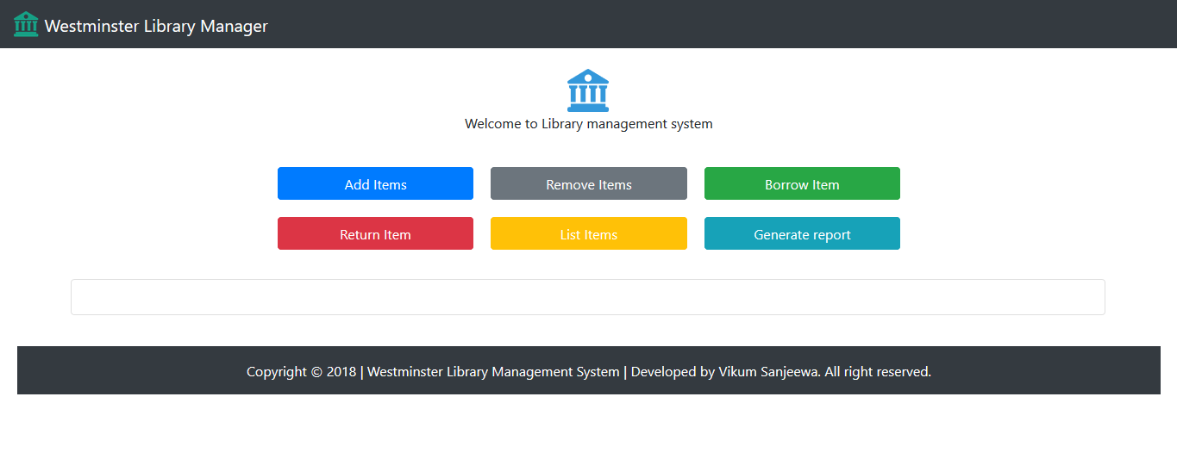

## Add item menu

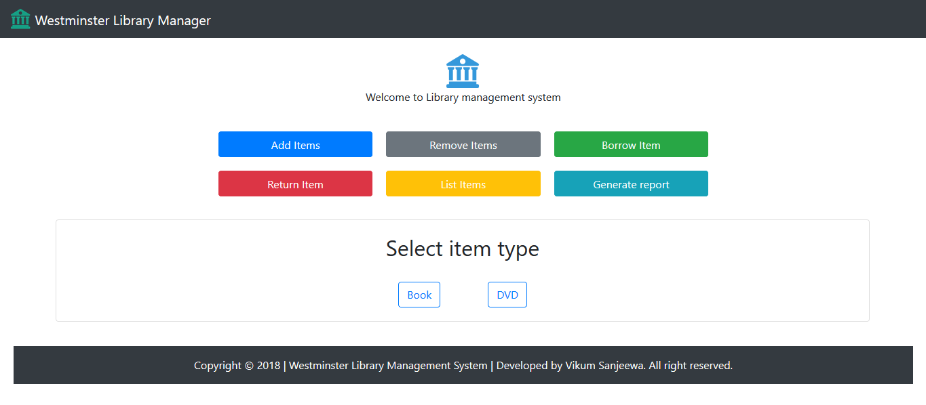

## Form to add books

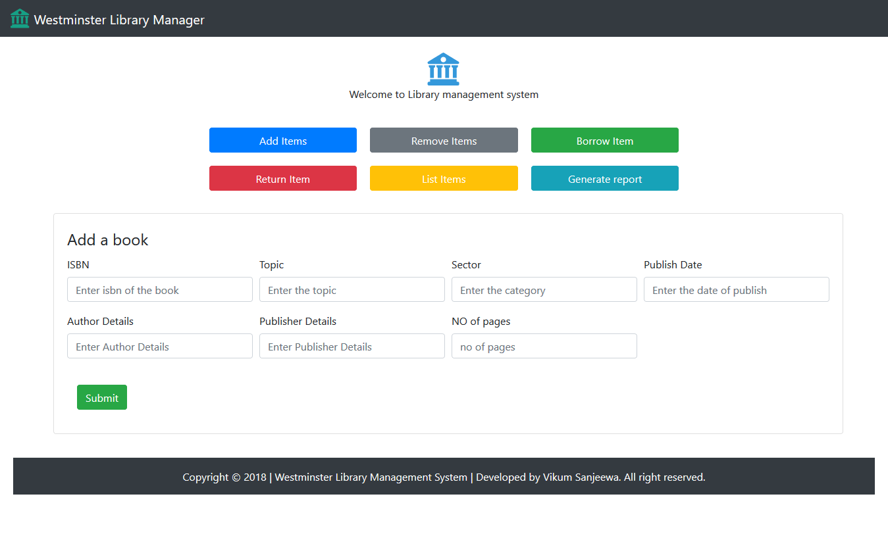

## Form to add DVD

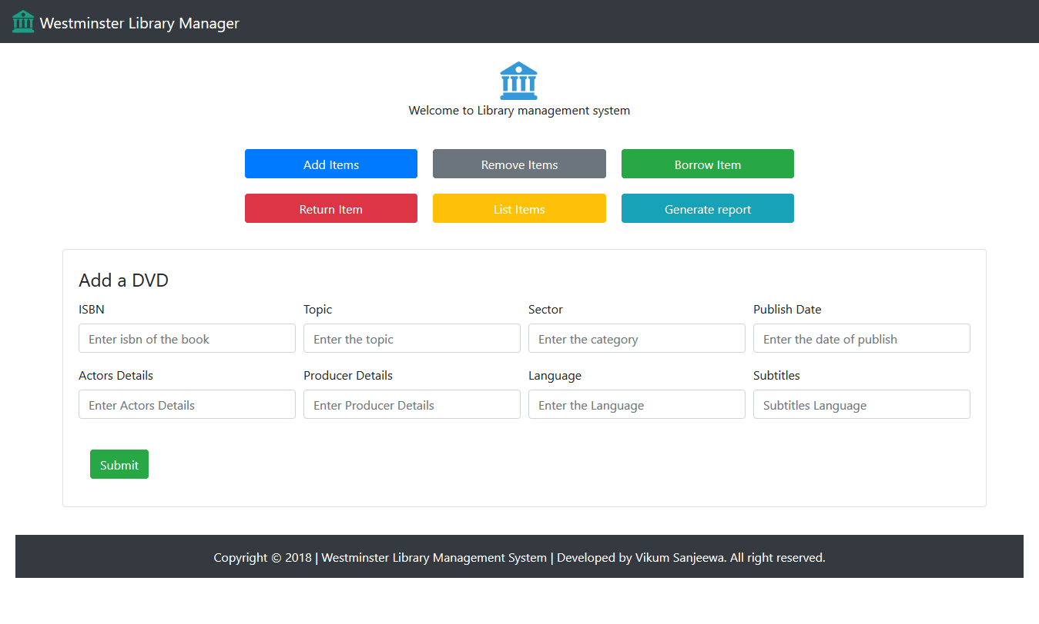

## Remove item

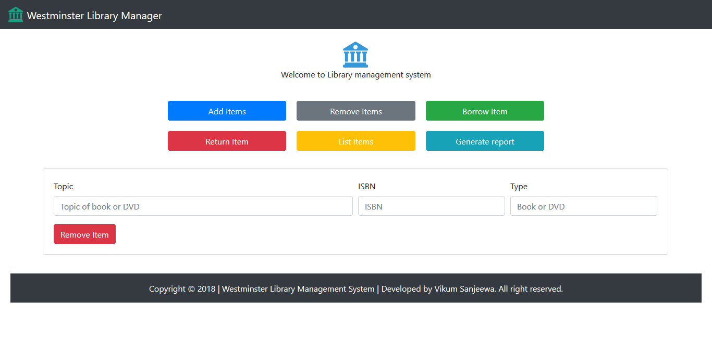

## Borrow item

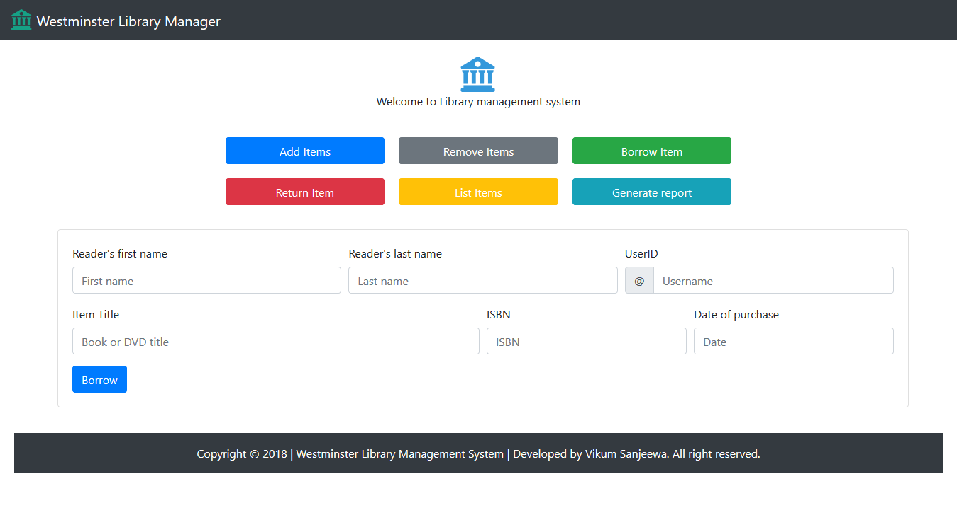

## Return item

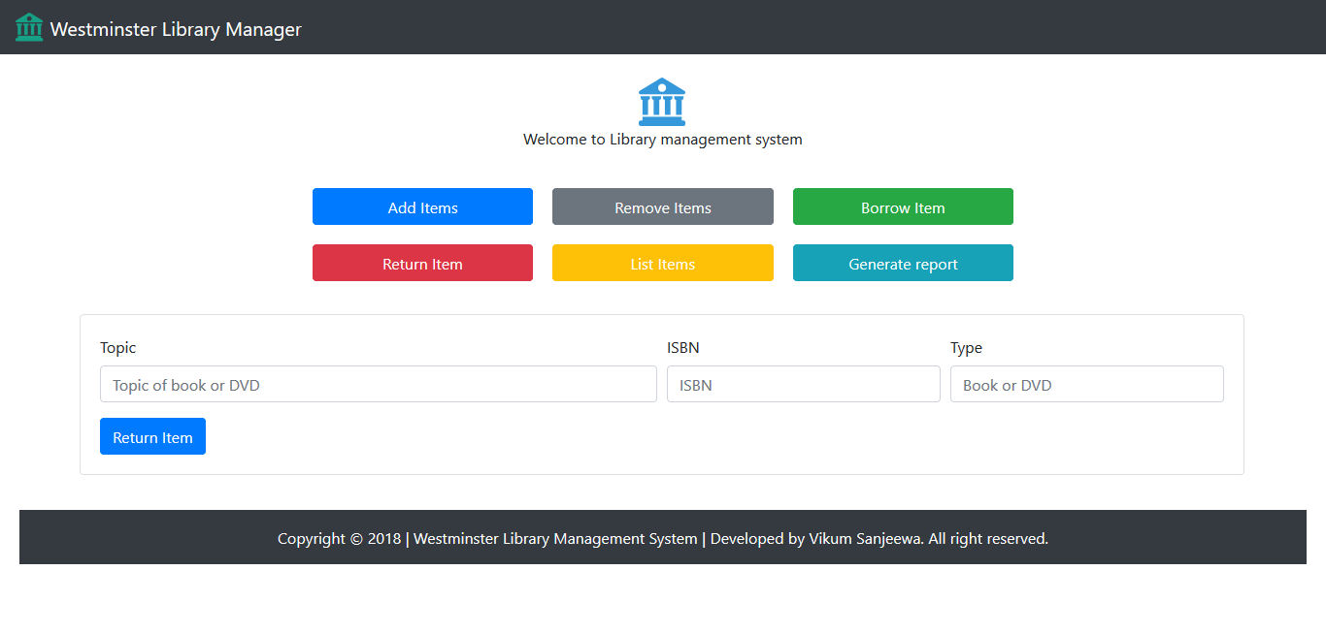

## Generate report

## List items

